
ONN-X2S A0

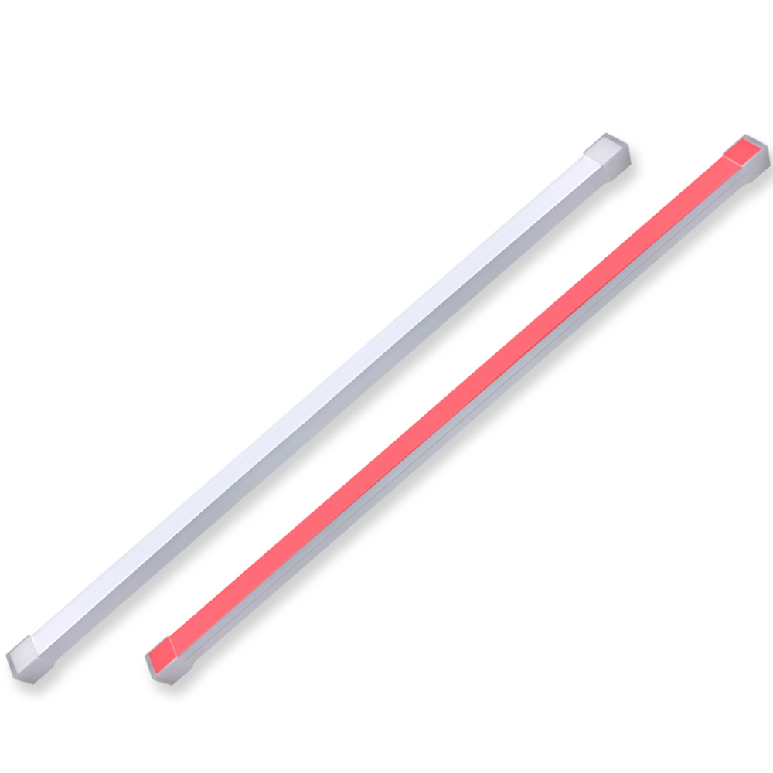
LED signal bar light ONN-X2S
Introduction:
- ONN-X2S is designed as indicator light as well as decoration light for machine.
- Waterproof and foldable , ip rating: IP67 (Silicone Neon Sleeve)
- Length can be customized according to your application.
- Tri colors(RYG) on one layer, show different states of machine.
- High-Quality Silicone Material,Strong Light Transmission

Application:
CNC machine work: engraving machine, EDM machine etc.

Warranty: 2 years
Certification: CE, RoHS

Dimension(mm):

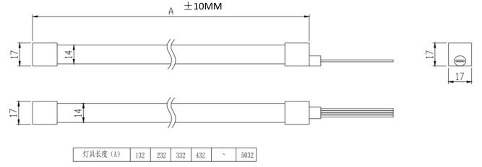

Wire connection:
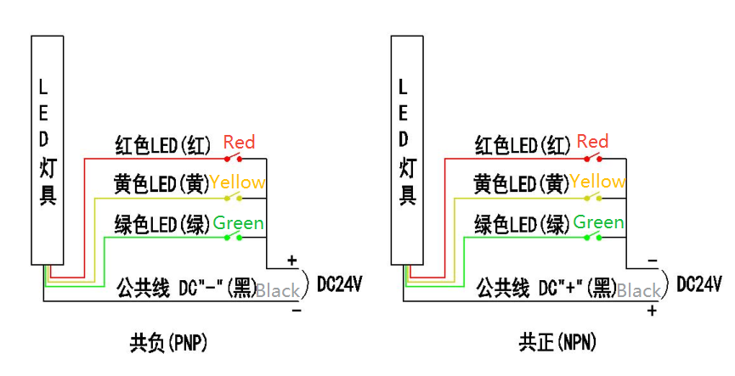

Ordering code:
Parameter:
Model No. | ONN-X2S
Input voltage(current) | DC24V
IP rating | IP67
Beam angle | 110 deg
Color | Red, Yellow, Green, RYG
Material | Silicone neon tubing
Lifetime | 50,000 hours
Lamp bead model | 5050
Working current | 600mA /M

ONN X2S - 700 RYG B
Model No.

Connection type

Z. NPN
B. PNP

Length(mm):
200
700
1200
1750
1900

Color
Red, Yellow, Green, RYG

Shenzhen Onn Semi-conductor lighting Co.,Ltd
Mobile : +86-18268698736 Fax: +86-755-27871421 Web: www.onnled.net 1/1
Add: Haofeng Industrial Park NO.2 Zone, Xinhe, Bao’an District, Shenzhen, China.

